Friends of the Calaveras County Library

Board Meeting Minutes- December 14, 2022

Meeting called to order at 9:05 am. Several members attended via ZOOM.

Members Present: Pru Starr (President/West Point) Diane Jarvi (Secretary/AC FOTL), Carolyn Lipnick (Copper FOTL), Charnette Boylan (SA/FOTL), Mary Ann Evans (VS/FOTL), Nancy Murray via Zoom (Murphys/FOTL), Bob Dean (At-large), Shirley Huberty (Treasurer/At Large), Martha Rubin via Zoom (Arnold/FOTL, Ray Waller (Moke Hill/FOTL).

Ex-Officio Members & Guests: Nancy Giddens (County Librarian), Phil Guttierrez (Literacy Coordinator).

Members Absent: Karen Eggleston.
__________________________________________________________________

Today’s Agenda and November minutes approved. [M/S/A]

Adult Literacy: CALAVERAS ADULT LITERACY - DECEMBER)
Staff Resources: Phil Guttierrez, M.A., Literacy Coordinator and Ann Seely, Literacy Community Liaison (.4 FTE)
TOTAL REVENUE: $100,120 (estimated) and Transfer from SFR Fund $11,520.55 (estimated) = $111,640.55
Expenditures: Salaries and Employee Services: $102,958.55
Services & Supplies: $8,682.00
Total Expenditures: $111,640.55 (estimated)
Tax Insert Donations to date = $3,600.
Instructions: Essential Education Computer Network Program, Remote and Education Packets (ADF) with Individual Education Plans (IEPs).
Program Participation: Main Library, Calaveras County HHS and branch library sites 14/ADF 10 (study packets delivered) = 24
GED Testing – Pearson-Vue

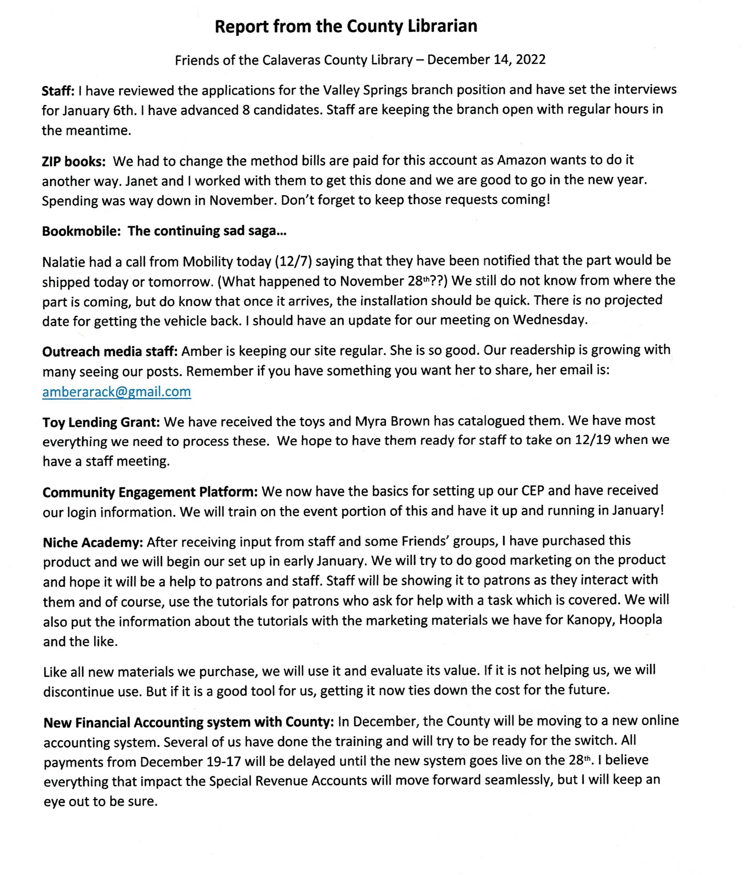

Treasurer: Financial Report NOVEMBER 2022

Wells Fargo Checking Account......General Fund...........................$90,478.62
Book Fund Designated ........................................................................$65.00
Book Mobile Designated ...............................................................$18,473.33
Literacy Fund .................................................................................$7,315.13
West Point Account ........................................................................$9,472.85
Bank Balance November 30, 2022.................................................$125,804.93
PayPal .............................................................................................. $390.75
Wells Fargo Checking - PayPal ....................................................... $1,000.00
This bank account receives PayPal funds. Minimum balance $1,000.
Total Income ................................................................................. $3,846.65
Expenditures ...................................................................................$4,828.71
Net Income ......................................................................................($982.06)

FIDELITY
Initial Investment...........................................................................$697,000.00
Value as of 10-31–2022 $764,937.58 ⇧$18,797.02
over last month Restricted for Bookmobile Use ...............................$116,938.62
Submitted by Shirley Huberty, Treasurer [M/S/A accepted report and proposed 2023 budget].

OLD BUSINESS:
Update of purchase of Veteran computers: we are waiting for the Veterans officer to get back to us on the computers he would like.

Building Sign: Shirley will contact Angels Sheet Metal to see what the cost would be to change the sign on the front of the building to include the names of the women.

Landscaping: Shirley has gone ahead and contacted the gardeners about the weed spraying.

NEW BUSINESS:
Enterprise Foundation Grant: Pru applied for a Enterprise Foundation Grant and was awarded $2,000. Amotion was made to apply this to the new Niche program [M/S/A].

Wish List: Bob Dean asked if we could add a “wish list for 2023” to the new business agenda. Bob would like to see us explore adding a science fair next year. Martha suggested a Community Garden for Arnold. Pru would like to see more parent involvement, and Charnette would like to see us bring back the Trivia Bee and/or do something to be more social.

BRANCH REPORTS:

Angels Camp: The Friends had their Poinsettia fundraiser again this year, and it was very successful. They also held a Story Time Christmas party and had 11 children.

Arnold: Arnold Friends had a holiday luncheon for their volunteers, and about 30 attended. They also had a kids holiday party. Herb has retired from their Board. They are interested in starting a community garden. At the end of April or early May, they are talking about having some type of fundraiser at the local Moose Lodge.

Copper: Tried a soup event again, but had no sales. They are working on their used book sales room. A volunteer is making them some new bookshelves.

Moke Hill: The local school “marched” all the kids over to the library and they were given free books. Their Open House event was also very successful.

Murphys: Their first Speaker Event last month was a big success with 52 people attending. They entered a float in the local parade which was fun. They are looking for a Story Time person.

San Andreas: Planning a holiday party this Saturday. Will include food, music, stories and Mr. & Mrs. Santa Claus. Also working on a volunteer lunch.

Valley Springs: Participated in the local VS Christmas parade and gave away 300+ books. They are looking into having a story time for kids ages 4-6.

West Point: Not closing their Friends grooup as they have recruited 5 new volunteers.

Meeting adjourned 10:35. Minutes submitted by Diane Jarvi.

Next meeting will be in on January 11th at 9:00 in San Andreas.

